Container Management Demo

Delivery Guide

About this document
Before presenting the Demo
Environment and Demo Preparation
Module 1 - Console Overview
✔️The different perspectives in the OpenShift Console
✔️The Main Dashboard
✔️The Events page
✔️The Software Catalog
✔️The Topology view
✔️The embedded Web Terminal
✔️The Observability dashboard
✔️The User Management features
✔️The Quick Starts
Module 2 - Deploying COTS and existing applications
✔️Deploying COTS as Operators - example: Crunchy PostgreSQL
✔️Deploying COTS as Operators - example: Confluent
✔️Deploying COTS as Helm Charts - example: SQL Server
✔️Deploying existing applications - Online Boutique
Module 3 - Secure by Default
✔️Security & Compliance
✔️ RBAC
✔️ Introduction to Network Security
Module 4 - Cluster Operations
✔️ Full-Stack Over-The-Air (OTA) Upgrades
✔️ Self-Sustaining Hardware: The Machine API
✔️ Intelligent Cluster Troubleshooting (OpenShift Lightspeed)
Module 5 - Advanced Cluster Management
Module 6 - Advanced Cluster Security (RHACS)

About this document
This delivery guide focuses specifically on the Container Management Demo.

It is essential to read this document thoroughly and complete all necessary preparation before presenting the material to the customer.

Note that this demo addresses only the Container Management Technical Deep Dive (TDP). Further relevant material is available here.

A Container Management Platform is a trusted and consistent solution to deploy and run containers, improving efficiency and scalability of containerized workloads at scale. By abstracting away the underlying infrastructure, containers make it faster and easier to deploy and run workloads. This also boosts consistency and portability, allowing software to run reliably across different environments, from data centers to edge locations. These containers include:
- Independent Software Vendors (ISVs): Deliver containerized COTS workloads to their customers.
- Containers built outside of OpenShift: Customers who built containers outside of the OpenShift application platform and need a container management platform to deploy on.

💡Important! This demo does not cover Application Platform use cases. This demo is not suitable for customers interested in using an application platform to develop, build and deploy their own applications.

Before presenting the Demo
The Container Management Demo is structured into various modules, each focusing on a distinct aspect of container management. This demo is designed for customization; it should not be presented in full but rather adapted to suit the specific needs of each customer. Prior to the meeting, confirm that all necessary information is available to ensure the demo is delivered effectively.

- Identify the customer's intended workloads for their container management platform. This is crucial for verifying that the preferred technologies are supported and certified for use on OpenShift.

- Inquire about their container runtime strategy:
- Are they planning to use different Kubernetes distributions?
- Do they currently utilize an alternative container platform?
- Are they, or do they intend to be, running Kubernetes on a hyperscaler?
This information is key to tailoring the cluster management module to their needs.
- Consider the audience's focus on container security. Are security team members attending the meeting? If security isn't a primary concern, avoid overwhelming the audience by presenting the comprehensive Advanced Container Security module.

Environment and Demo Preparation

Instructions to provision the demo environment are here

💡Important: to show the Topology view, you will need to deploy the Online Boutique application.

💡Important: to demonstrate OpenShift Lightspeed, you need to configure the LLM model

💡Optional: Customize the Web Console to show the customer’s logo - Adding a custom logo and product name

Module 1 - Console Overview
While the underlying API of OpenShift Container Platform is 100% Kubernetes, plain Kubernetes focuses primarily on container orchestration and requires you to manually add and integrate your own solutions for authentication, networking, security, monitoring, and log management.

The OpenShift Container Platform web console bridges this gap by providing an out-of-the-box, highly integrated graphical user interface that manages both standard Kubernetes resources and advanced platform-level requirements.

✔️The different perspectives in the OpenShift Console
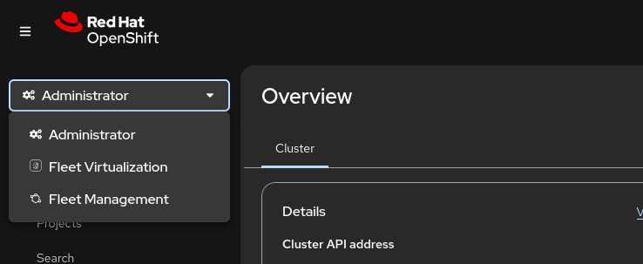

Starting with OpenShift 4.19 (released in mid-2025), the console shifted from a dual-perspective model to a Unified Perspective. This change acknowledges the evolving "Platform Engineer" role, where the line between application development and infrastructure management has blurred.

While the console is now unified by default, it effectively organizes the cluster into three functional "areas" rather than rigid perspectives:
- Core Platform (The New Default): This is the core experience. It merges the Administrator tools (nodes, storage, operators) with Developer tools (topology, builds, serverless). You no longer need to switch modes to jump from a high-level application view to the underlying pod or node details.
- Virtualization Perspective: When the OpenShift Virtualization Operator is installed, the console intelligently surfaces a virtualization-heavy view. It includes a Multi-cluster Tree-View and a dedicated Virtualization Dashboard designed to make VMware or RHV admins feel at home.
- Fleet Management Perspective: This perspective is the realization of the "single pane of glass" for multi-cluster operations. It is officially surfaced through the integration of Red Hat Advanced Cluster Management (ACM) directly into the primary OpenShift console. It moves the focus from managing a single cluster to managing a distributed "fleet" of clusters across on-premises, cloud, and edge environments.

✔️The Main Dashboard

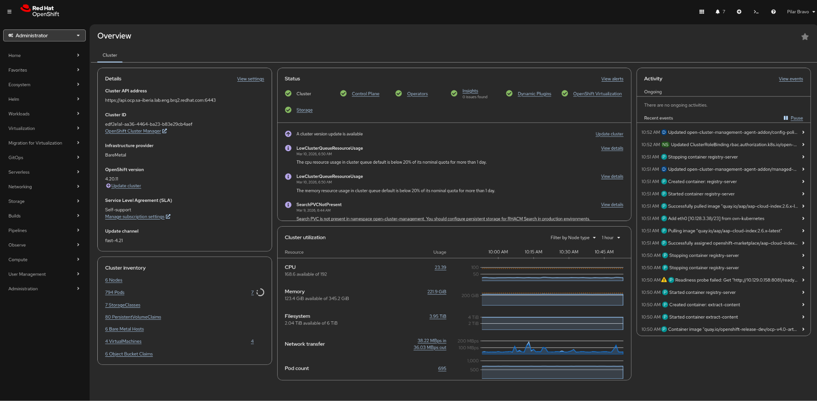

The dashboard is organized into several Cards that aggregate live data from Prometheus and the Kubernetes API:
- Details Card: Shows high-level metadata, including the Cluster ID, Provider (e.g., vSphere, AWS, Bare Metal), OpenShift Version, and the Update Status (indicating if an update is available or in progress).
- Status Card: A color-coded health indicator. It displays a "Green Tick" for healthy clusters or alerts (Warning/Critical) if there are issues. You can click on specific sub-components like Control Plane or Storage to see exactly where a failure is occurring.
- Cluster Inventory Card: Provides a total count of critical resources. It lists the number of Nodes, Pods, Storage Claims, and—if OpenShift Virtualization is active—the total number of Virtual Machines. Icons (like an exclamation point) appear next to any resource type currently in a failed state.
- Cluster Utilization Card: Displays real-time graphs for CPU Usage, Memory Allocation, Storage Consumption, and Network Throughput. You can toggle the time range (e.g., 1 hour, 6 hours) directly on the card.
- Activity Card: A live feed of cluster events. It highlights recent significant actions, such as pod crashes, successful node scale-ups, or VM migrations.

✔️The Events page
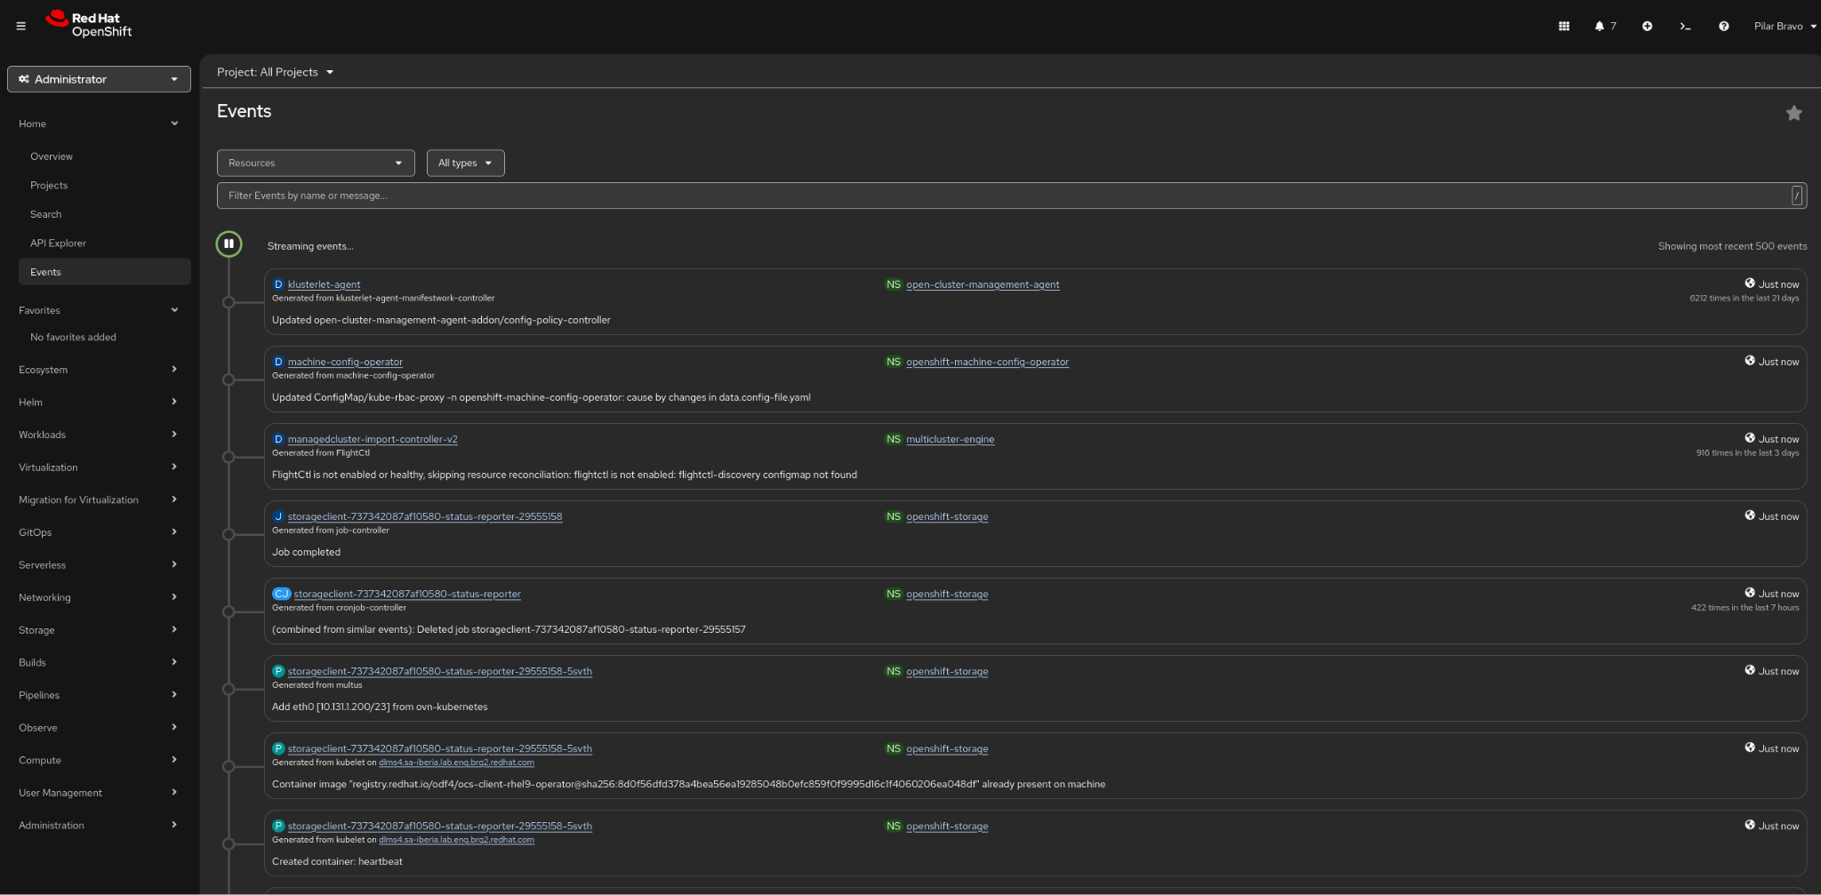

In OpenShift Container Platform, the events page provides a unified view of the system events occurring within your cluster. Events are records of real-world activities or state changes that happen to API objects, allowing developers and administrators to monitor and troubleshoot system components.

Because events are treated as informative, supplemental data, they have a limited retention time and will eventually expire and be deleted to prevent filling up etcd storage.
💡 Note: It is possible to modify the retention time for events, but you cannot increase it beyond the default 3 hours. Because events are stored in the cluster's etcd database, their lifespan is strictly limited to prevent etcd from filling up, which could cause latency and cluster performance issues. If your goal is to maintain a permanent security or administrative trail, you should use API Audit Logging rather than standard cluster events. You can deploy the OpenShift Logging subsystem to automatically collect, manage, and permanently forward these audit and infrastructure logs to external storage systems (like AWS S3, Google Cloud Storage, or Splunk)

You can view events in the OpenShift Container Platform web console in a few different ways depending on the scope of what you are investigating:
- Project-level Events: Navigate to Home → Events and select your project from the drop-down menu to see all events scoped to that specific namespace.
- Resource-specific Events: Many objects, such as pods, deployments, or services, have their own dedicated Events tab on their details page (e.g., navigating to Home → Projects → → ). This tab filters the view to show only the events related to that specific object.
- High-level Overview: You can also see a list of ongoing cluster activities and recent events directly from the Home → Overview dashboard.
The Events page includes several filtering options to help you pinpoint specific issues:
- Resources list: Allows you to select a specific resource to see only the events associated with it.
- All Types list: Allows you to filter events by their severity type, such as showing only Warning or Normal events.
- Search bar: Allows you to search for specific events by typing names or keywords found in the event messages.
The events shown on the page cover a wide range of system activities. Common categories include:
- Container events: Indicates the lifecycle of a container, such as Created, Started, Killing, Preempting, or BackOff (when restarting a failed container is delayed).
- Image events: Tracks the status of container images, such as Pulling, Pulled, InspectFailed, or Failed.
- Health events: Shows when a container is marked as Unhealthy.
- Configuration events: Shows issues like FailedValidation for pod configurations.
- Node events: Displays infrastructure-related events, which are typically found in the default namespace.

✔️The Software Catalog
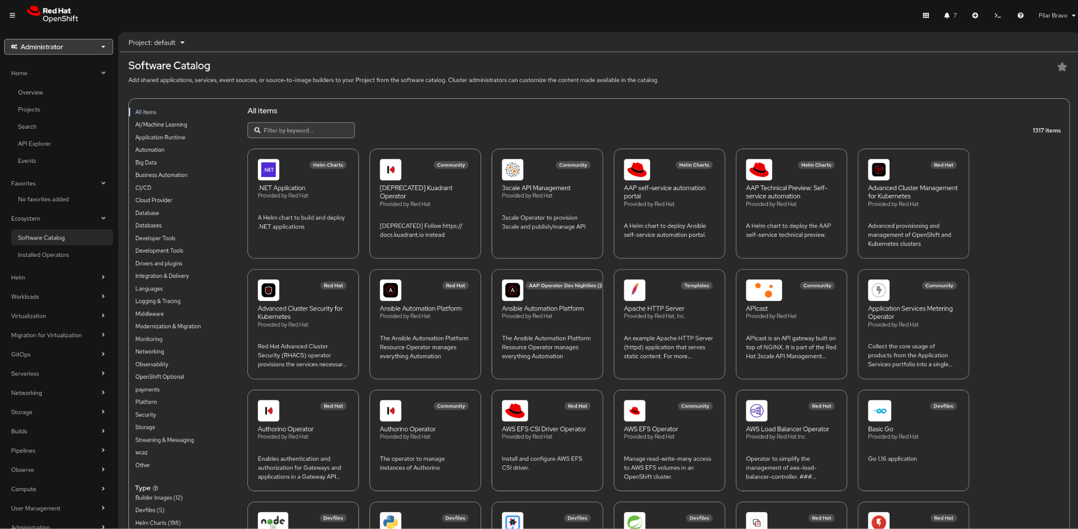

The software catalog is the OpenShift Container Platform web console interface that allows cluster administrators and authorized users to discover, select, and install software on their cluster.

Here is a breakdown of the core advantages it brings to your workflow:
1. Self-Service Empowerment
The biggest win is autonomy. Developers can provision databases, languages, and services without opening a ticket for the infrastructure team.
- Speed: Provisioning a PostgreSQL database or a Node.js runtime takes seconds.
- Guardrails: While it feels like total freedom for the developer, the admins still control what appears in the catalog, ensuring everything stays within company policy.
2. Standardized Templates
The catalog uses Templates and Helm Charts to ensure consistency across the organization.
- No "Snowflakes": Every developer deploying a specific service uses the same validated configuration.
- Reduced Errors: Since the deployment logic is pre-baked into the template, the risk of manual configuration errors (like forgetting a persistent volume or an environment variable) is significantly lowered.
3. Broad Ecosystem Integration
The catalog isn't just for Red Hat products; it aggregates resources from multiple sources:
- OperatorHub: Access to sophisticated, managed services (like MongoDB or Redis) that handle their own updates and backups.
- Helm Charts: Direct integration with the massive Kubernetes Helm ecosystem.
- Source-to-Image (S2I): Allows you to point the catalog at a Git repository; OpenShift then builds the container image and deploys it automatically.
4. Simplified Discovery
In a large enterprise, finding the "right" version of a tool can be a nightmare. The catalog organizes resources into logical categories:
- Languages: Java, Python, .NET, Go, etc.
- Databases: MariaDB, MySQL, MongoDB.
- Middleware: Kafka (AMQ Streams), JBoss, etc.

✔️The Topology view
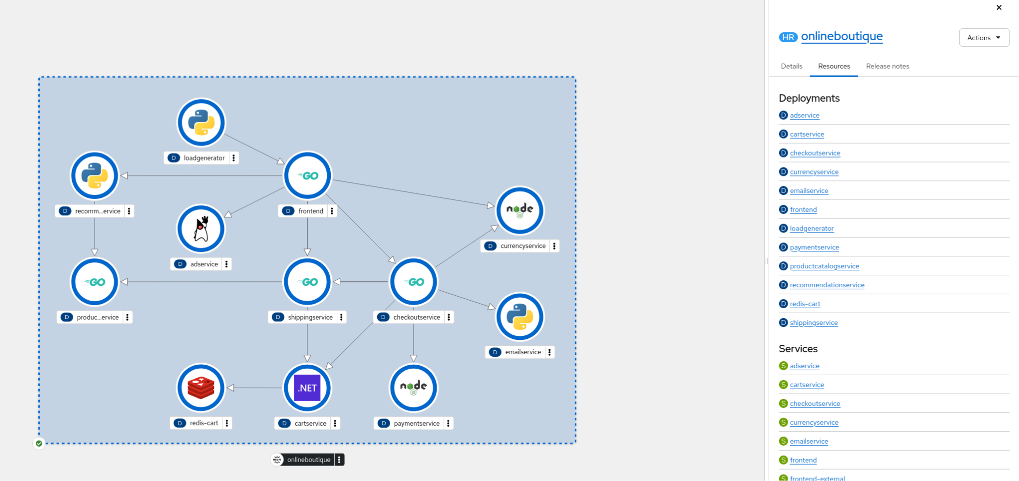
To view the application's topology, first switch to the project where the online boutique application was deployed. You can select any service to see the available options. For the Frontend microservice, the platform will display the associated pods, services, and the active route. Click the route to open the running application.

✔️The embedded Web Terminal

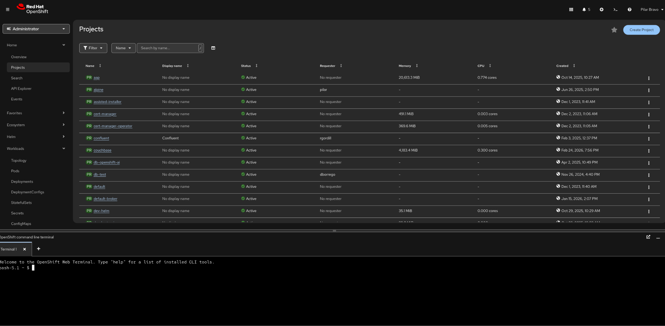

The embedded web terminal in the OpenShift Container Platform web console provides a command-line interface directly within your browser.

Here are the specific advantages it provides:
1. Zero Installation & Maintenance
The terminal is entirely browser-based, meaning you don't need to install or update the OpenShift CLI (oc) or Kubernetes CLI (kubectl) on your local machine.
- Pre-installed Tooling: It comes "out of the box" with a massive suite of tools, including oc, kubectl, helm, kn (Serverless), tkn (Pipelines), and utilities like jq and git.
- Always Up-to-Date: The tools in the web terminal are automatically matched to the version of the cluster you are running, preventing "version mismatch" errors.
2. Automatic Authentication
One of the most tedious parts of working with Kubernetes is managing login tokens and context switching.
- Instant Login: The web terminal uses your existing console session. When you open it, you are already logged in with your current user permissions and scoped to the project you were just viewing.
- Security: It eliminates the need to store sensitive kubeconfig files or long-lived tokens on your local laptop.
3. Contextual Awareness
The terminal is tightly integrated with the console's UI.
- Project Sync: If you are looking at a specific project (namespace) in the Developer perspective and open the terminal, it defaults to that project automatically.
- Side-by-Side Troubleshooting: You can keep the terminal open as a "drawer" at the bottom of the screen. This allows you to watch logs or resource statuses in the GUI while simultaneously running commands to fix issues.
4. Accessibility in Restricted Environments
For many developers in highly regulated industries (like banking or government), installing custom binaries on a work laptop is blocked by IT policy.
- Bypass Local Restrictions: Since the terminal runs as a pod inside the cluster, you only need a web browser to perform advanced CLI tasks.
- Low Bandwidth: It is often more responsive than a local CLI when working over a slow VPN, as the actual "work" is happening within the cluster's network.
5. Multi-User Isolation
Every time a user opens a web terminal, OpenShift provisions a dedicated, private pod for that session.
- Customization: Users can customize their shell environment during the session.
- Resource Control: Admins can set quotas on these terminal pods to ensure that developers don't accidentally consume too many cluster resources while running CLI tasks.

✔️The Observability dashboard

TO-DO with 4.21 and tech preview features

✔️The User Management features
In OpenShift, the User Management section of the web console serves as the administrative bridge between your external corporate directory and the internal Kubernetes RBAC (Role-Based Access Control).
Having these tools embedded directly in the console—rather than relying solely on the CLI—offers several "high-velocity" advantages for cluster administrators.
1. Simplified Identity Provider (IdP) onboarding
Go to Administration -> Cluster Settings -> Configuration -> OAuth
In Identity Providers click Add to show the available options
Instead of manually crafting complex Custom Resource (CR) YAML files, the console provides a wizard-driven interface to connect your cluster to external identity sources like LDAP, GitHub, or Google.
- Advantage: You can configure, test, and troubleshoot your connection to an IdP (Identity Provider) in minutes. The UI validates your parameters (like URLs and Secret names) before you apply them, reducing the risk of locking yourself out of the cluster.

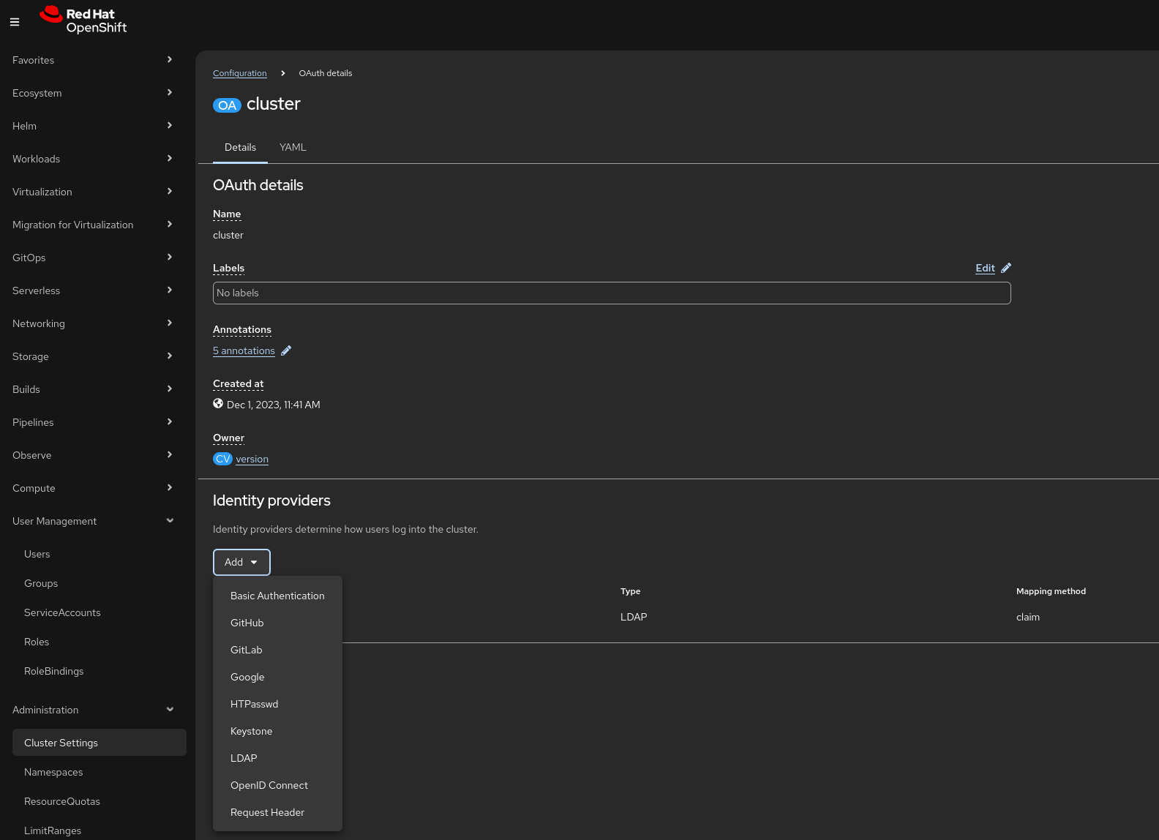

2. Powerful user impersonation for debugging
You can click on a specific user in the User Management > Users list and select "Impersonate User."
- Advantage: This allows an admin to see exactly what a specific developer sees. If a developer complains they "can't see the monitoring tab," you can impersonate them to verify if your RBAC policies are actually working as intended without needing their password.

3. Visual RBAC Mapping
Understanding who has access to what in a large cluster with hundreds of namespaces is notoriously difficult. The OpenShift console provides a clear, searchable table of RoleBindings and ClusterRoleBindings.
- Advantage: You can instantly see which users are "Cluster Admins" versus "Project Viewers." It also makes it easy to spot "orphaned" permissions—where a user has been deleted from your company's LDAP but their internal OpenShift User object or RoleBinding still exists.

4. Group Management & LDAP Sync Visibility
Managing users individually is a nightmare. OpenShift relies on Groups to scale permissions.
- Advantage: The console allows you to manually create local groups for quick projects or, more importantly, monitor the status of your LDAP Group Sync. If a sync fails, the console's event stream will highlight the specific error (e.g., "invalid credentials" or "search base not found"), allowing for much faster resolution than digging through logs in the openshift-authentication namespace.

✔️The Quick Starts

In OpenShift, Quick Starts are interactive, step-by-step tutorials built directly into the web console. They are designed to provide "hands-on" learning without forcing the user to leave the platform for external documentation.
Think of them as in-app GPS for your cluster—they don't just tell you what to do; they point to the specific buttons you need to click.
Where to find them
Quick Starts are located in two primary places:
- The Help Menu: Click the (?) icon in the top header and select Quick Starts. This opens a catalog of all available tutorials.
- The "Add" Page: In the Developer Perspective, the "Getting Started" section often features specific quick starts tailored to new projects.
Advantages:
1. Real-Time UI Highlighting
When you start a task (e.g., "Create a Serverless function"), the Quick Start side panel will actually animate or highlight the specific element in the console you need to click next.
- Benefit: It eliminates the "where is that button?" frustration common with traditional documentation.
2. Verification Steps
Each task within a Quick Start ends with a check. The system will ask, "Did your build succeed?" or "Can you see the route?"
- Success Feedback: If you click "Yes," you get a satisfying green checkmark.
- Error Correction: If you click "No," the quick start provides a "Helpful hint" or a link to common troubleshooting steps specifically for that task.
3. Content Variety
The Quick Start catalog has expanded beyond basic "Hello World" apps to include:
- AI/ML Onboarding: Deploying Large Language Models (LLMs) or setting up OpenShift AI workbenches.
- Serverless & Eventing: Walking through the "Scale to Zero" logic.
- Operator Demos: Many Operators now "inject" their own Quick Starts into your cluster upon installation, teaching you how to use that specific tool (e.g., CrunchyDB or Advanced Cluster Management).
4. Customizable for Internal Teams
Administrators can create Custom Quick Starts using a simple YAML-based ConsoleQuickStart resource.
- The Use Case: Platform Engineering teams use this to create "Internal Golden Paths." You can create a quick start that teaches your developers exactly how to deploy an app according to your company's security and naming standards.

Module 2 - Deploying COTS and existing applications

In OpenShift, deploying third-party software typically follows one of three paths depending on whether you need a simple installation or long-term automated management.
While Operators and Helm Charts are the primary industry standards, OpenShift also supports native Templates. Here is how they differ and when to use each.

1. Operators (The "Smart" Way)
Operators are the gold standard for complex, stateful applications (like databases or monitoring tools). An Operator is essentially a "human operator in a box"—it’s a piece of software that knows how to install, manage, and even repair another application.
- How to deploy: Access the OperatorHub in the OpenShift console. Search for the software (e.g., MongoDB, Grafana), click Install, and then create an "Instance" of that software.
- Key Advantage: It handles Day-2 operations. If a database node fails, the Operator fixes it. If you need a backup, the Operator can trigger it. It also manages its own updates seamlessly.
- Best For: Databases (PostgreSQL, Redis), Messaging (Kafka), and Infrastructure tools (Service Mesh, Logging).

2. Helm Charts (The "Package Manager" Way)
Helm is often called the "apt" or "yum" of Kubernetes. It packages all the necessary YAML files into a single versioned unit called a Chart.
- How to deploy: * Console: Go to the Developer Catalog, filter by Helm Charts, and select one to install via a form-based UI.
  - CLI: Use the command helm install <name> <chart-repo>.
- Key Advantage: It is highly flexible and platform-agnostic. Almost every major software project provides a Helm chart. It’s excellent for templating different environments (e.g., using one chart to deploy to Dev, Test, and Prod with different values).
- Best For: Stateless applications, web frontends, and community software that doesn't require complex lifecycle management.

3. OpenShift Templates (The "Native" Way)
Templates are an OpenShift-specific way to define a set of objects that can be parameterized.
- How to deploy: Found in the Developer Catalog under "Templates."
- Key Advantage: They are native to OpenShift and very lightweight. They are perfect for internal "Golden Path" templates created by your own DevOps team for internal developers to use.
- Best For: Simple, internal company standards and legacy OpenShift 3.x workflows.

✔️Deploying COTS as Operators - example: Crunchy PostgreSQL
To increase the demo's impact, substitute this example with a certified Operator deployment of a technology the customer is currently using, if feasible. This example only illustrates a software deployment via an Operator.

The example is adapted from https://github.com/CrunchyData/postgres-operator-examples/tree/main

Before starting this part of the demo you need to create a new project to deploy all the Crunchy components.
Go to Home -> Projects and click on Create Project.

Then follow these steps to deploy Crunchy as an Operator:

- Access the Software Catalog page in Ecosystem -> Catalog

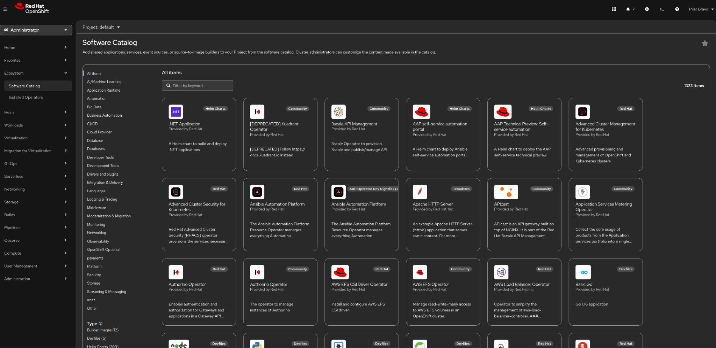

- Show some of the certified technologies that are in the catalog, as well as the available filters.
- Filter by Operators
- Type Crunchy in the search box
- Click on Crunchy Postgres for Kubernetes
- Click Install
- Perform the following changes in the default configuration:
  - Select Installation mode -> A specific namespace in the cluster
  - Select the namespace you have created for Crunchy
  - Click Install
- When the operator has installed successfully, click View Operator

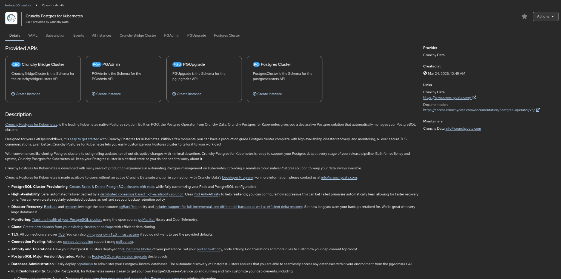

Deploy an HA Database

- Click on Postgres Cluster -> Create instance
- Go to the yaml view and paste this (it is an example configuration):

apiVersion: postgres-operator.crunchydata.com/v1
kind: PostgresCluster
metadata:
name: hippo-ha
spec:
postgresVersion: 18
instances:
- name: pgha1
replicas: 2
dataVolumeClaimSpec:
accessModes:
- "ReadWriteOnce"
resources:
requests:
storage: 1Gi
affinity:
podAntiAffinity:
preferredDuringSchedulingIgnoredDuringExecution:
- weight: 1
podAffinityTerm:
topologyKey: kubernetes.io/hostname
labelSelector:
matchLabels:
postgres-operator.crunchydata.com/cluster: hippo-ha
postgres-operator.crunchydata.com/instance-set: pgha1
backups:
pgbackrest:
repos:
- name: repo1
volume:
volumeClaimSpec:
accessModes:
- "ReadWriteOnce"
resources:
requests:
storage: 1Gi
proxy:
pgBouncer:
replicas: 2
affinity:
podAntiAffinity:
preferredDuringSchedulingIgnoredDuringExecution:
- weight: 1
podAffinityTerm:
topologyKey: kubernetes.io/hostname
labelSelector:
matchLabels:
postgres-operator.crunchydata.com/cluster: hippo-ha
postgres-operator.crunchydata.com/role: pgbouncer

- Check that the resources have been created successfully

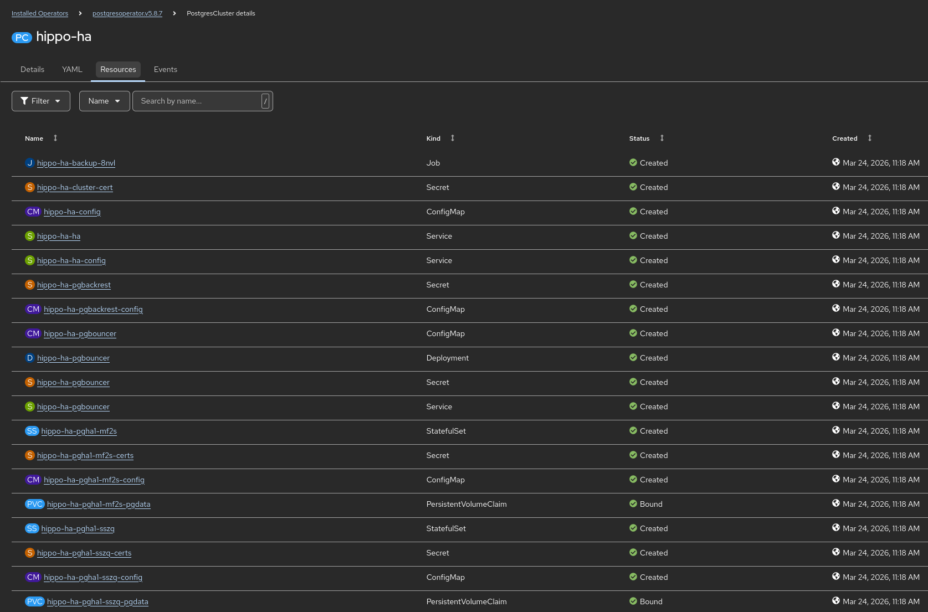

Deploy pgAdmin

In order to manage the database, we will deploy PGAdmin.
- Go back to Installed Operators -> Crunchy Postgres for Kubernetes
- Click on PGAdmin
- Go to the yaml view and paste this:

apiVersion: postgres-operator.crunchydata.com/v1beta1
kind: PGAdmin
metadata:
name: rhino
spec:
users:
- username: rhino@example.com
role: Administrator
passwordRef:
name: pgadmin-password-secret
key: rhino-password
dataVolumeClaimSpec:
accessModes:
- "ReadWriteOnce"
resources:
requests:
storage: 1Gi
serverGroups:
- name: supply
# An empty selector selects all postgresclusters in the Namespace
postgresClusterSelector: {}
serviceName: hippo-pgadmin
config:
settings:
AUTHENTICATION_SOURCES: ['internal']

- Check that the resources have been created successfully

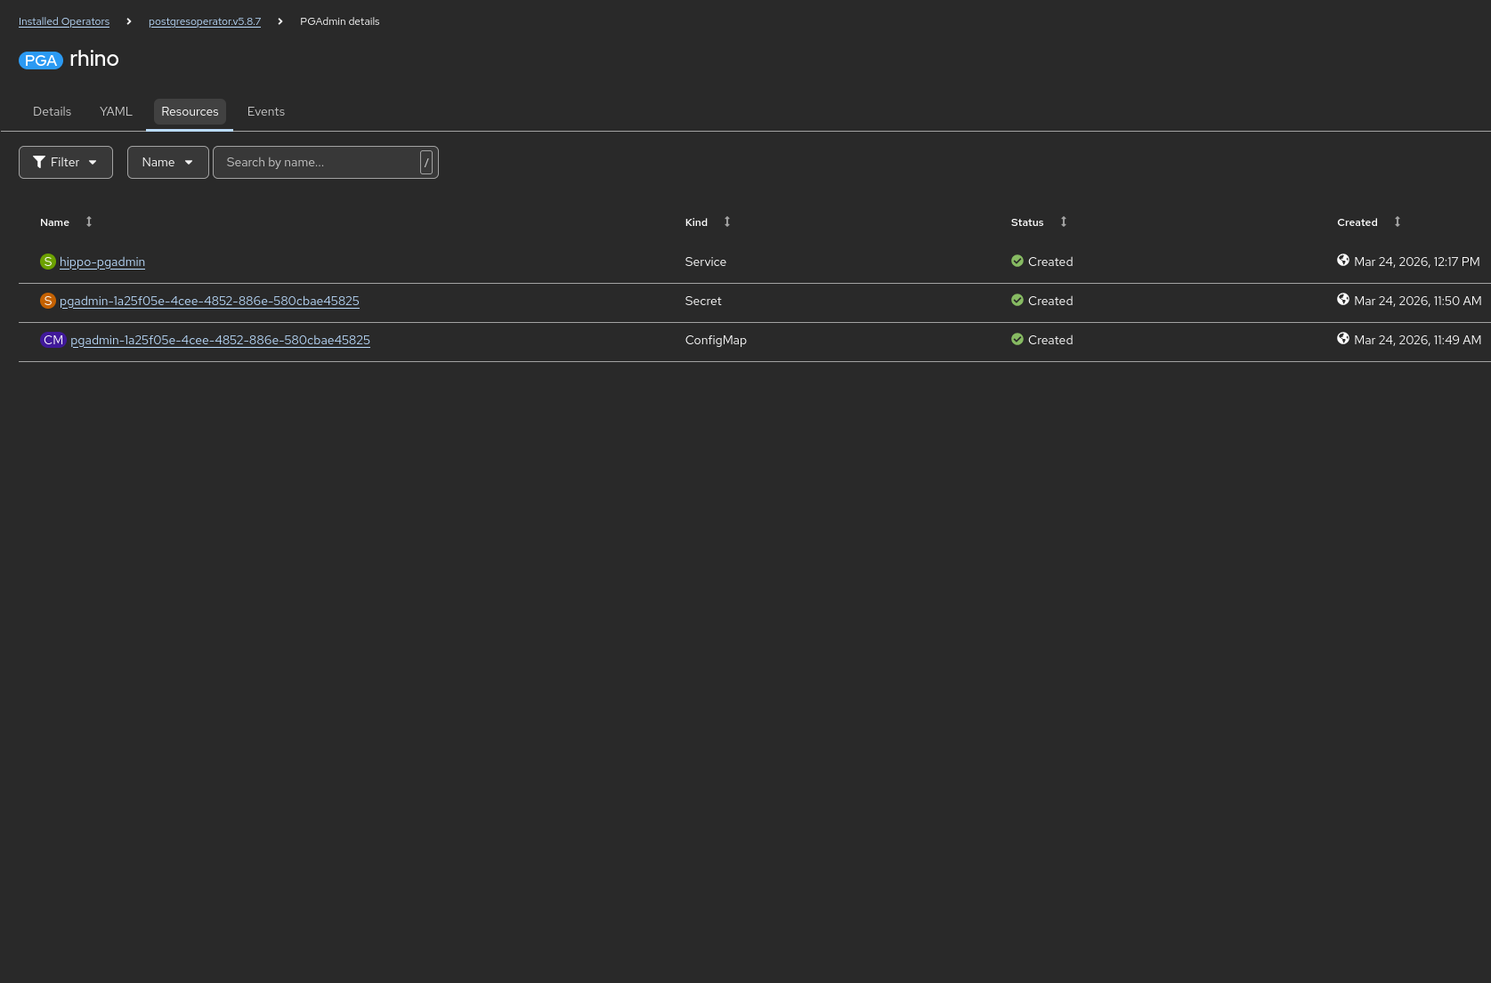

- Create a route to access the PGAdmin console

Go to Networking -> Routes, click on Create Route and paste this content:
kind: Route
apiVersion: route.openshift.io/v1
metadata:
name: route-pgadmin
spec:
to:
kind: Service
name: hippo-pgadmin
weight: 100
port:
targetPort: 5050
tls:
termination: edge
insecureEdgeTerminationPolicy: Redirect
wildcardPolicy: None

Click on the new route to check that PGAdmin is deployed correctly.

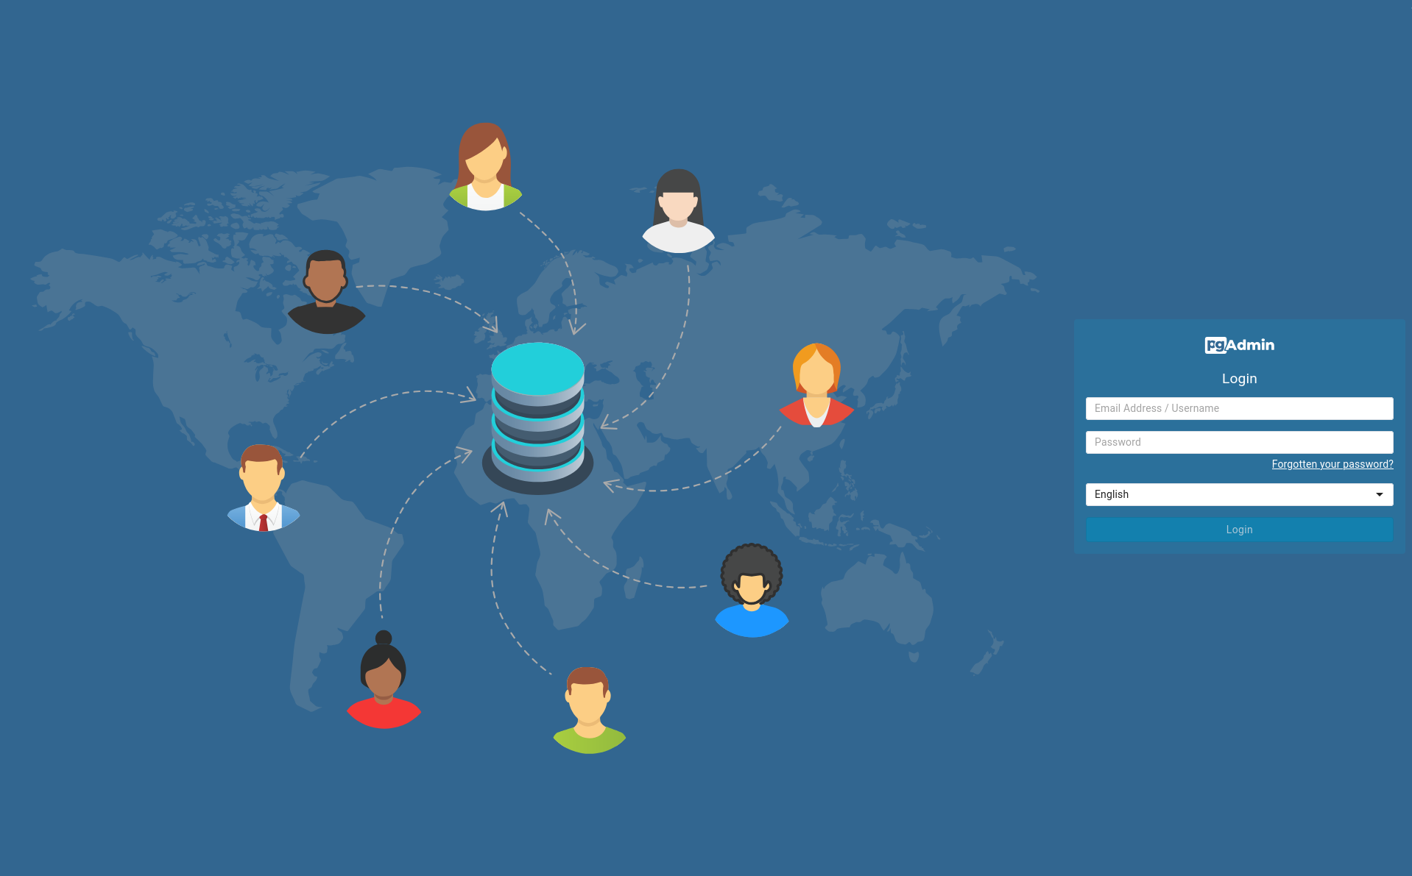

- Create a secret for the PGAdmin console credentials

oc create secret generic pgadmin-password-secret \
--from-literal=rhino-password=redhat01

- Access the PGAdmin console with credentials rhino@example.com/redhat01
- Connect to the database in the PGAdmin console. Look for the password in Workloads -> Secrets -> hippo-ha-pguser-hippo-ha

- Create a sample table

Access PGAdmin and run this script to create a sample table:

CREATE SCHEMA demo_app AUTHORIZATION "hippo-ha";
SET search_path TO demo_app;
CREATE TABLE demo_transactions (
id SERIAL PRIMARY KEY,
customer_name TEXT NOT NULL,
amount DECIMAL(10,2),
processed_at TIMESTAMP DEFAULT CURRENT_TIMESTAMP
);

INSERT INTO demo_transactions (customer_name, amount) VALUES
('Acme Corp', 1500.00),
('Globex', 2450.50),
('Soylent Corp', 99.99);

SELECT * FROM demo_transactions;

Self-Healing demonstration
In a traditional environment, if a database node fails, someone gets called at 3 AM. On OpenShift, the Operator is our 24/7 SRE.
- Open the OpenShift Topology View in Workloads -> Topology and show the Crunchy deployment
- Now go to Workloads -> Pods
- Find the pod labeled role=master (one with a name similar to hippo-ha-pgha1)
- Delete it.
- Go back to the topology view and see how the Operator immediately detects the loss. It is currently promoting one of the replicas to 'Primary' and provisioning a new 'Standby' to replace the one you just killed.
- Go back to pgAdmin and run
SET search_path TO demo_app;
SELECT * FROM demo_transactions;

Scale-on-Demand demonstration
Imagine it's Black Friday. We need more read capacity. Usually, that’s a ticket to the Infra team that takes weeks
- Go to the PostgresCluster YAML in the Console.
- Change replicas: 2 to replicas: 3.
- Click Save.
- Watch the Topology: A new pod spins up, joins the cluster, and automatically starts replicating data.
- We just scaled our data layer horizontally in 30 seconds with zero manual configuration.
Security & Binding demonstration
Security is usually the hardest part of database management. How do we get credentials to the developers safely?
- Navigate to Workloads > Secrets.
- Show the Secret named hippo-ha-pguser-hippo-ha
- The Operator automatically rotated these passwords and stored them in an encrypted Secret. To connect an app, the developer just 'binds' to this Secret. No passwords in Git, no manual credential handling.

✔️Deploying COTS as Operators - example: Confluent
TODO - extra example

✔️Deploying COTS as Helm Charts - example: SQL Server
Explain the different use cases for Operators and Helm Charts:
Operators and Helm are not mutually exclusive; in a mature OpenShift environment, they often function as a layered stack. While Helm is the best tool for "Day 1" (packaging and templating), Operators are the masters of "Day 2" (ongoing state management).
In many organizations, the choice depends on the nature of the workload:
- Use Helm for Stateless Apps: For simple web frontends or APIs where "Day 2" is just "restart if it crashes," Helm is more than enough. It provides versioning, easy rollbacks, and environment-specific variable injection.
- Use Operators for Stateful Apps: For databases (Postgres, MongoDB) or complex middleware (Kafka/Confluent), an Operator is essential. It understands the application's internal state—knowing, for instance, that it shouldn't reboot a database node while a backup is in progress.
This is just an example of a Helm chart for SQL Server for illustration purposes. It is based on Microsoft official documentation to deploy SQL Server container clusters.
First, create a new project to deploy SQL Server. Go to Home -> Projects and create a new project.
Go to Helm -> Repositories and click on Create Helm Repository.
Fill out the following data:
- Scope Type: Cluster scoped
- Name: sqlserver-helm-charts
- URL: https://mpbravo.github.io/helm-charts/
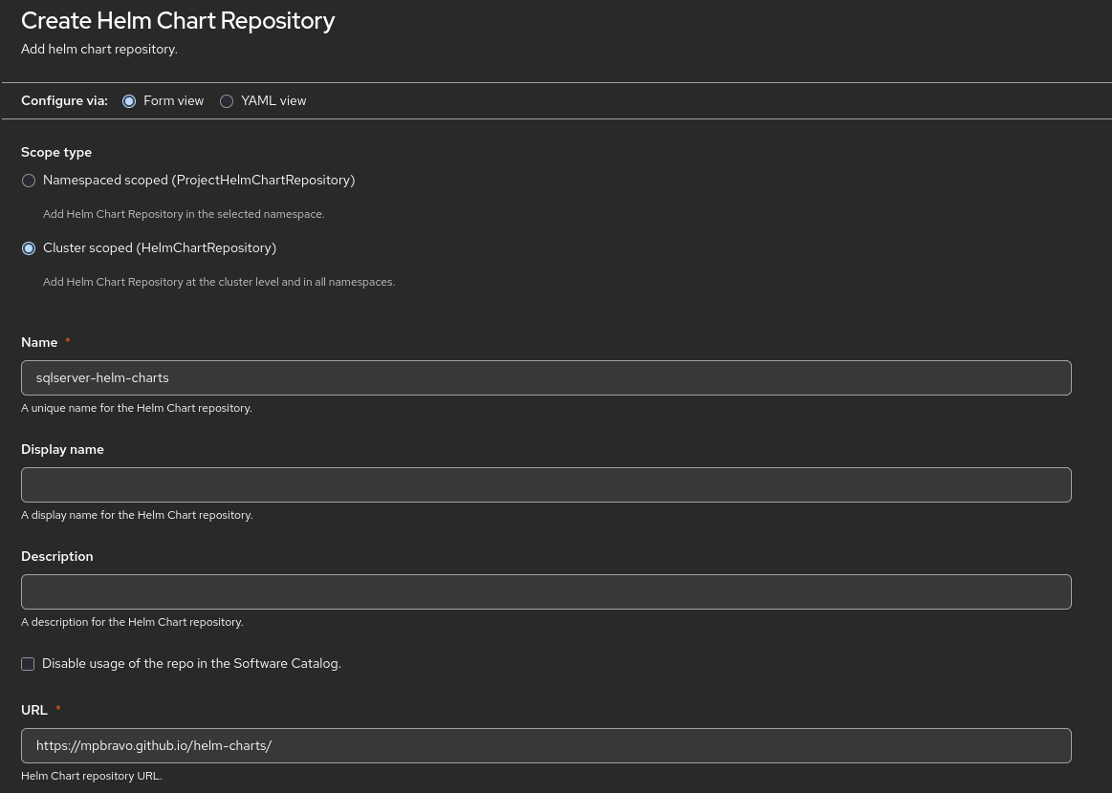
Go to Ecosystem -> Software Catalog
Filter by Helm Charts, and in Helm Repositories, select the one we have just created. The SQL Server should show up.
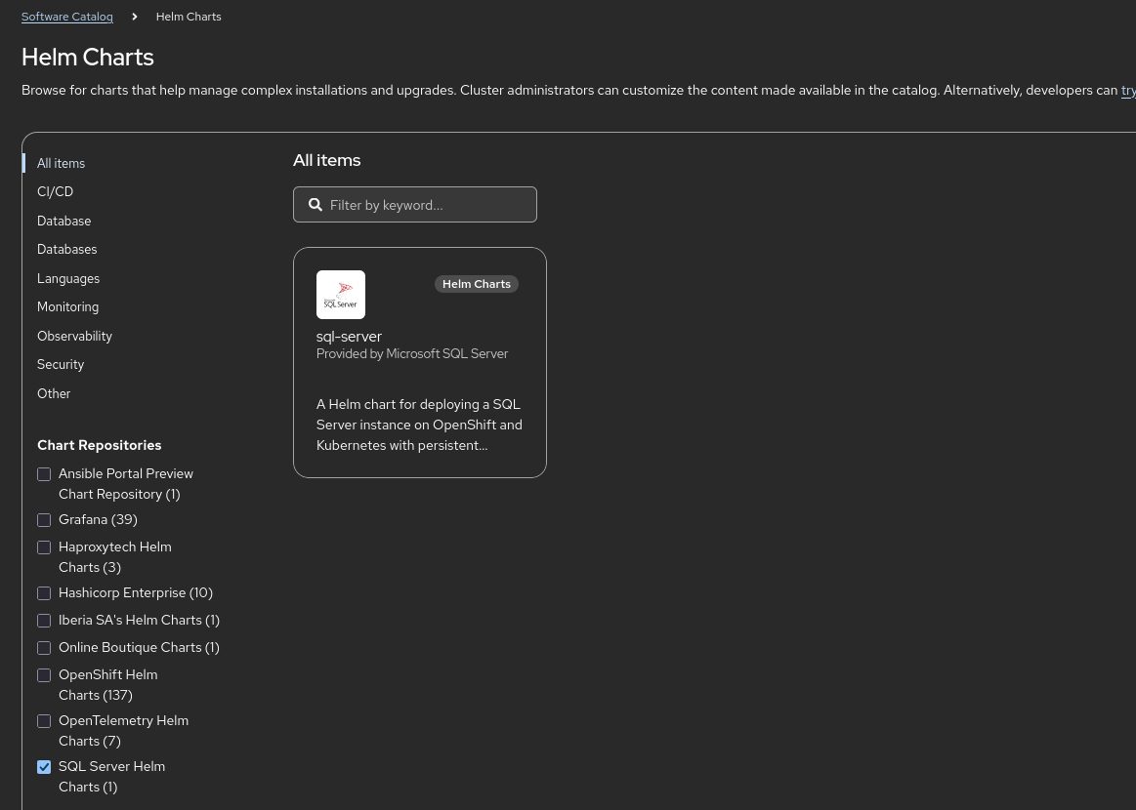
Click on the SQL Server Helm Chart and click on Create.
Expand the form and add the SA password for the new database. Then click on Create.
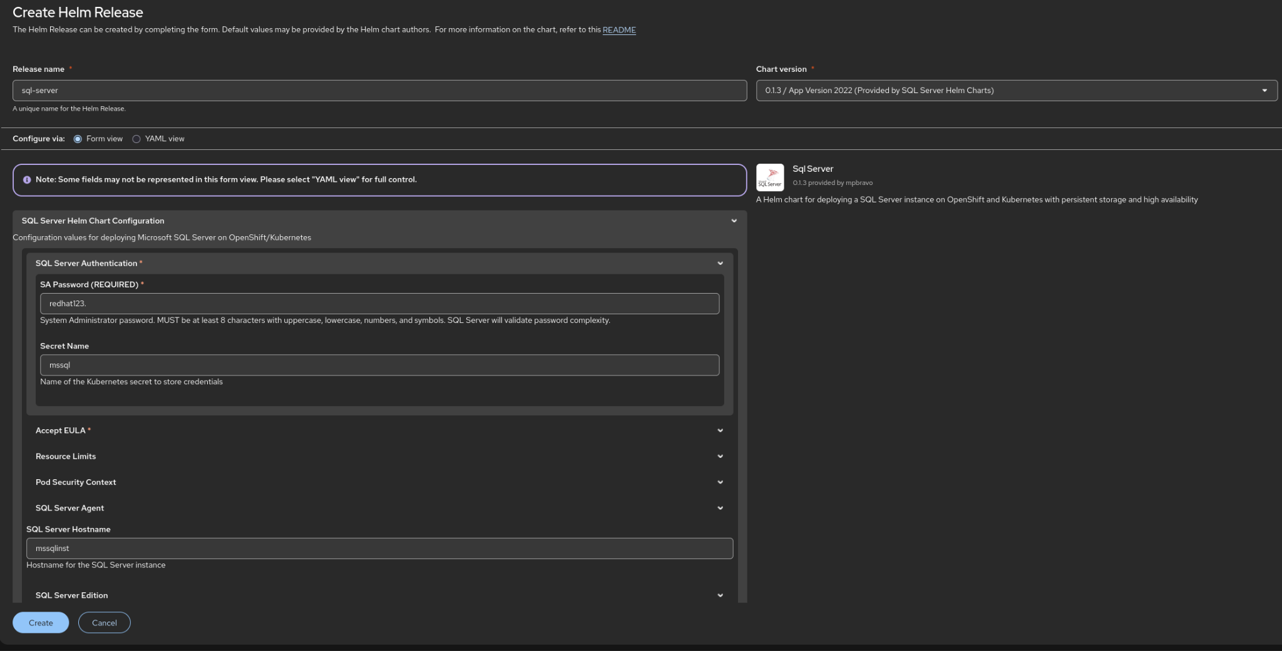
If everything is ok, then you will be redirected to the Topology view with the SQL Server pod running.
You can connect to the SQL Server instance through node ports, using one of the nodes IP/hostname and the port showing here:
> oc get services
NAME TYPE CLUSTER-IP EXTERNAL-IP PORT(S) AGE
mssql-deployment LoadBalancer 172.30.38.133 <pending> 1433:30701/TCP 14m
> sqlcmd -S node-hostname,30701 -U sa -P redhat123. -C

Note: node ports are disallowed in most customers, this is just an example to check connection to the database.
Check that the server is alive:
1> SELECT @@VERSION;
2> GO

------------------------------------------------------------------------------------------------------------------------------------------------------------------------------------------------------------------------------------------------------------------------------------------------------------
Microsoft SQL Server 2022 (RTM-CU23) (KB5078297) - 16.0.4236.2 (X64)
Jan 22 2026 17:50:56
Copyright (C) 2022 Microsoft Corporation
Developer Edition (64-bit) on Linux (Ubuntu 22.04.5 LTS) <X64>

(1 rows affected)

✔️Deploying existing applications - Online Boutique
The Online Boutique (formerly known as Hipster Shop) is a cloud-native, microservices-based demo application created by Google Cloud. It is widely used by developers and architects to learn how to build, deploy, and manage complex, modern applications.
We have a Helm chart to deploy this application. It is a complex, cloud native, microservices based application to illustrate how to deploy and manage these types of applications in OpenShift.
Create a new project to deploy this application.
Go to Helm -> Repositories and click on Create Helm Repository.
Fill out the following data:
- Scope Type: Cluster scoped
- Name: online-boutique-charts
- URL: https://mpbravo.github.io/online-boutique-helm/
Go to Ecosystem -> Software Catalog
Filter by Helm Charts, and in Helm Repositories, select the one we have just created. The Online Boutique should show up.
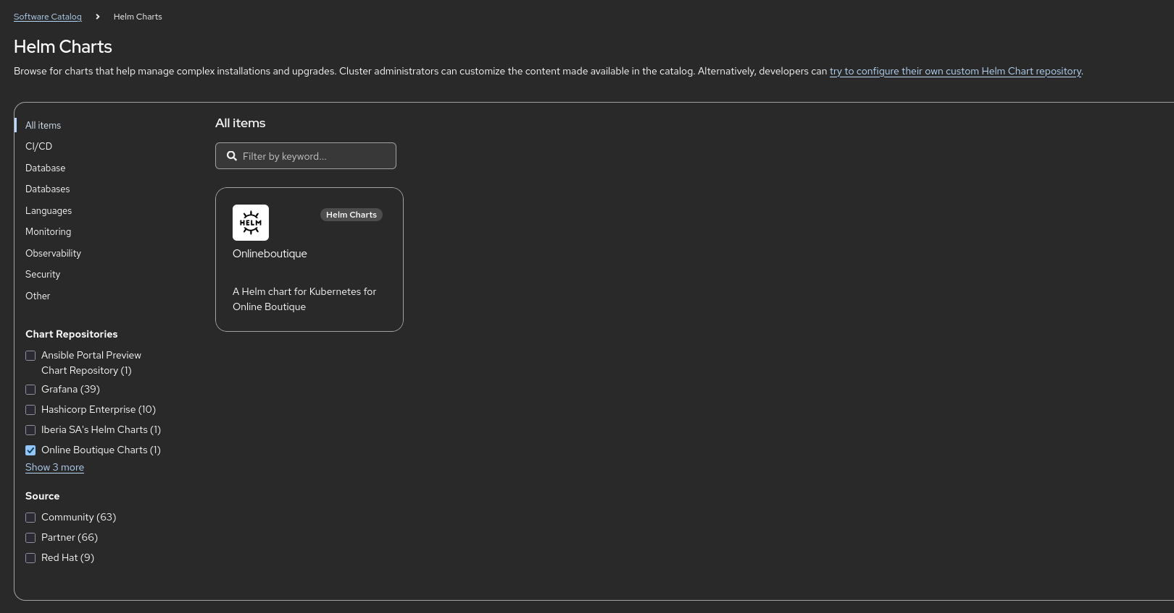
Click on the Online Boutique Helm Chart and click on Create.
After a few moments, the application should show in the Topology view. You can also test it by clicking on Networking -> Routes and accessing the web interface.
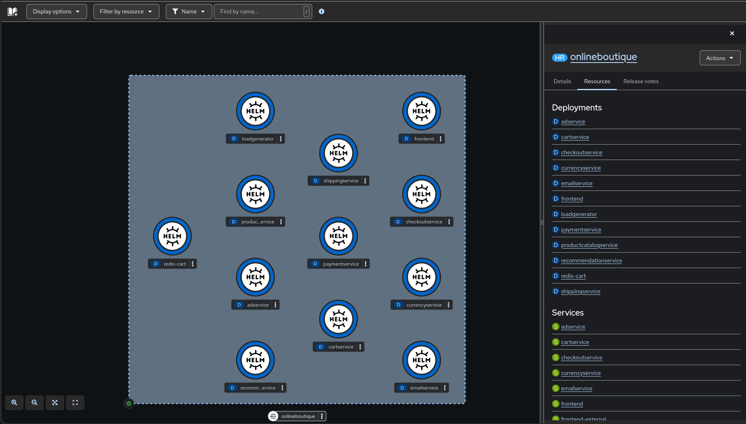

Module 3 - Secure by Default
This module is based on the work by Rodrigo Alvares about security. It only includes a few examples, but we recommend examining all of them in advance to prepare for the demo. All examples are here: https://github.com/ralvares/openshift-security-framework

✔️Security & Compliance
Based on https://github.com/ralvares/openshift-security-framework/blob/main/labs/basic/b1.adoc
OpenShift is famous for its strict Security Context Constraints (SCC).
Security Context Constraints (SCCs) are an OpenShift-specific security mechanism that governs what actions a pod can perform and what system privileges it has.

Think of RBAC as controlling who can manipulate API objects (e.g., "Can this user create a pod?"), while SCCs control what that pod is allowed to do to the underlying Linux host once it gets created (e.g., "Can this pod run as root or access the host’s file system?").
This built-in enforcement is exactly why OpenShift is considered "secure by default" compared to vanilla Kubernetes.

SCCs allow an administrator to define strict security boundaries for workloads. They control whether a pod or container can:
- Run as a privileged container.
- Request privilege escalation.
- Request specific Linux capabilities (or drop them).
- Use host directories as volumes.
- Use a specific SELinux context or container user ID (UID).
- Use host namespaces and networking.
- Allocate an FSGroup that owns the pod volumes or configure allowable supplemental groups.
- Require write access to its root file system.
- Use specific volume types or seccomp profiles.

OpenShift ships with several out-of-the-box SCCs. The absolute most common ones you’ll encounter are:
- restricted-v2 (The Default): Applied to almost all user workloads automatically. It strictly strips away root privileges, blocks access to the host network/volumes, and forces the container to run as an allocated non-root user ID.
- anyuid: Allows a container to run as any User ID, including root (UID 0). It maintains other guardrails (like blocking host filesystem access) but is highly useful for third-party container images that assume they have root access.
- privileged: Total control. This grants a pod absolute power over the host system. It is reserved almost exclusively for critical cluster infrastructure, system operators, or CNI plugins.
Try to run a "naughty" container from the public internet that requires root access. Example: Apache web server
- Create a new project to host the example, for instance demo-security
- Go to Workloads -> Deployments and create a new Deployment
- Configure the following image: docker.io/httpd:latest
- Set the number of replicas to 1 for simplicity
- Create the deployment and see that the container does not start:
AH00558: httpd: Could not reliably determine the server's fully qualified domain name, using 10.130.0.237. Set the 'ServerName' directive globally to suppress this message
(13)Permission denied: AH00072: make_sock: could not bind to address [::]:80
(13)Permission denied: AH00072: make_sock: could not bind to address 0.0.0.0:80
no listening sockets available, shutting down
AH00015: Unable to open logs
- Explain that the reason it does not work is because by default, OpenShift runs containers using an arbitrarily assigned high-number User ID (UID) (e.g., 1000750000). It does this for security—if a process escapes the container, it has no privileges on the host. The Apache image, however, is built to run as root (UID 0) so it can bind to port 80. When it hits OpenShift, it tries to write to the log files, realizes it isn't actually root, and crashes with Permission Denied.
- Changing privileged: true (a common workaround) won’t work on OpenShift because, as the OpenShift API server will reject the request with an error message stating that the user does not have permission to use that specific SCC.
- Now change the image to use a verified Red Hat UBI image ( registry.access.redhat.com/ubi9/httpd-24 ) that follows security best practices: runs as non-root, uses a non-privileged port (8080 instead of 80), and is curated, patched, and supported. The pod should run with no issues after the change.

✔️ RBAC
In a production environment, security is built on the Principle of Least Privilege: ensuring that users have exactly the amount of access they need to do their jobs—and nothing more. OpenShift makes this transition from 'total restriction' to 'managed access' seamless through the OpenShift console.

Role-Based Access Control (RBAC) in OpenShift is a fundamental security mechanism that determines whether a user, group, or service account is allowed to perform a specific action within a project or the cluster. By applying RBAC to Kubernetes namespaces, OpenShift ensures that multitenant applications remain securely isolated from one another. Authorization in OpenShift is governed by three primary objects:
- Rules: Sets of permitted actions (verbs) on specific objects. For example, a rule dictates whether a user can "create" or "get" pods.
- Roles: Collections of rules. A single role can contain multiple rules that specify exactly which actions and resources are allowed.
- Bindings: The explicit associations that link a user, group, or service account to a particular role.
- Levels of RBAC

OpenShift evaluates authorization using a two-level hierarchy:
- Cluster RBAC: These roles and bindings apply cluster-wide across all projects. A cluster role binding can only reference a cluster role.
- Local RBAC: These roles and bindings are scoped to a specific project. While local roles exist only within a single project, a local role binding can reference either a local role or a cluster role. This structure allows administrators to reuse common cluster roles across multiple projects while maintaining the flexibility to customize access inside individual projects through local roles.

OpenShift includes a set of pre-configured Default Cluster Roles that can be bound to users locally or cluster-wide. It is highly recommended not to manually modify these default cluster roles, as altering them can break cluster functionality. Common default roles include:
- cluster-admin: A super-user role that can perform any action in any project. When bound locally, it grants full control over every action and resource, including quotas, within that project.
- admin: A project manager role. If used in a local binding, an admin can view and modify any resource in the project except for the resource quota.
- basic-user: A user that can retrieve basic information about projects and other users.
- cluster-status: A user that can view basic cluster status information.
- edit and view: Default OpenShift roles that grant standard read/write or read-only access to project resources.

Log into the OpenShift Web Console.
- Look at the top left corner of the screen and ensure the dropdown is set to the Core Platform perspective.
- In the navigation menu, go to Home → Projects.
- Click the blue Create Project button on the right side.
- Name the project finance-frontend and click Create.

Instead of crafting a complex RoleBinding YAML file, we will use OpenShift’s built-in User Management interface to bind a pre-existing edit role to our user.
- In the left navigation menu, expand the User Management section and click on RoleBindings.
- At the top of the page, ensure your project filter dropdown is set to the project we just created: finance-frontend.
- Click the Create Binding button.
- Set the following fields in the wizard interface:
  - Binding Type: Namespace-wide role binding (RoleBinding)
  - Name: finance-developer-edit-binding
  - Namespace: finance-frontend (automatically set)
  - Role Name: Select edit from the dropdown list. (This built-in role allows users to deploy apps, pods, and routes but bars them from altering security settings or quotas).
  - Subject: User
  - Subject Name: dev-bob (Type the username of the developer account your enterprise identity provider maps).
- Click Create.

You will now see your newly created binding in the list, visually confirming that dev-bob is tied to the edit role within this scope.
Now, let’s step into the shoes of the developer to witness the strict boundaries enforced by the RBAC framework by using the Impersonation feature.
- In the top right corner of the screen, click on the user icon and select Impersonate User.
- Select dev-bob from the dropdown list and click Impersonate.
- You will now see the OpenShift console as if you were logged in as dev-bob.
- Click on the Project dropdown at the top.
- The Result: dev-bob can see finance-frontend perfectly, but all other business namespaces or core infrastructure projects are invisible to him.

✔️ Introduction to Network Security
Based on https://github.com/ralvares/openshift-security-framework/blob/main/labs/basic/b4.adoc

- Create a new project to host the demo, for instance demo-security
- Create a new deployment with the following data:
  - Name: api
  - Image: registry.access.redhat.com/ubi9/python-311
  - Replicas: 1 (expand Advanced Options to configure)
  - Change to yaml view to add the command to execute in the pod:
apiVersion: apps/v1
kind: Deployment
metadata:
namespace: demo-security
name: api
annotations: {}
spec:
selector:
matchLabels:
app: api
replicas: 1
template:
metadata:
labels:
app: api
spec:
containers:
- name: container
image: registry.access.redhat.com/ubi9/python-311
ports:
- containerPort: 8080
protocol: TCP
env: []
command: ["python3"]
args: ["-m", "http.server", "8080"]
imagePullSecrets: []
strategy:
type: RollingUpdate
rollingUpdate:
maxSurge: 25%
maxUnavailable: 25%
paused: false
- Create a service to expose the deployment. Go to Networking -> Services and copy the following yaml:
apiVersion: v1
kind: Service
metadata:
name: api-service
namespace: pilar-security
labels:
app: api
spec:
ports:
- protocol: TCP
port: 8080
targetPort: 8080
internalTrafficPolicy: Cluster
type: ClusterIP
ipFamilyPolicy: SingleStack
sessionAffinity: None
selector:
app: api
- Create a new pod with the following data:
  - Access the yaml view and paste the following:
apiVersion: v1
kind: Pod
metadata:
name: client-allowed
labels:
role: allowed
spec:
containers:
- name: ubi-container
image: registry.access.redhat.com/ubi9/ubi
command: ["sleep"]
args: ["infinity"]
- Create a second pod with the following data:
  - Access the yaml view and paste the following:
apiVersion: v1
kind: Pod
metadata:
name: client-denied
labels:
role: denied
spec:
containers:
- name: ubi-container
image: registry.access.redhat.com/ubi9/ubi
command: ["sleep"]
args: ["infinity"]

- Try to access the deployment from the two pods:
  - Access the terminal in the pod client-allowed and execute this command: curl -s -o /dev/null -w '%{http_code}\n' http://api-service:8080
  - Do the same with the pod client-denied.
  - Both should succeed with a 200 code.
- Now create a new network policy. Go to Networking -> Network Policies and fill out the form with this data:
  - Name: default-deny-ingress
  - Policy type: check “Deny all ingress traffic”
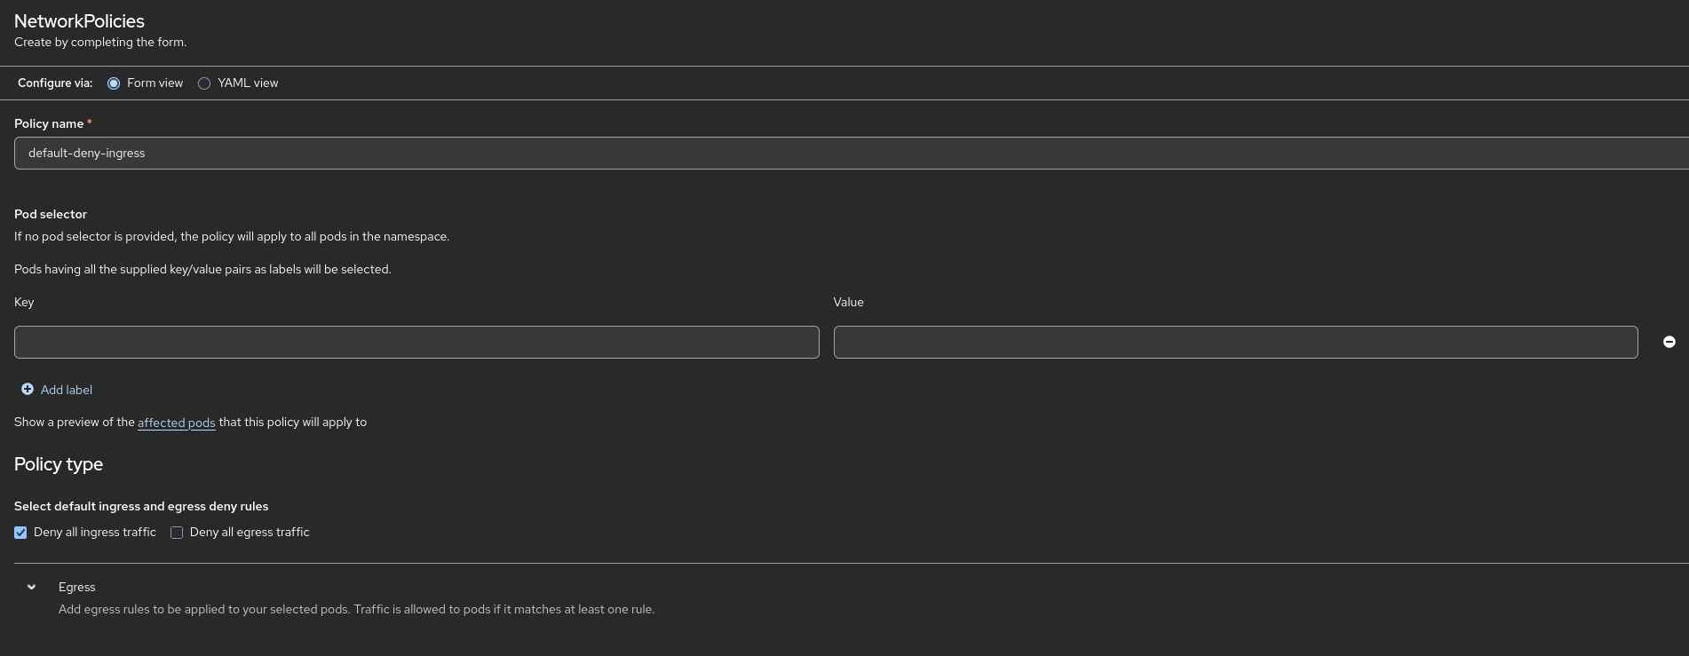
- Test the connections again to see that they are now blocked (timeout should be expected after 3 seconds):
  - Access the terminal in the poc client-allowed and execute this command: curl -s --max-time 3 -o /dev/null http://api-service:8080
  - Do the same in the pod client-denied
  - Now all connections are denied.
- The next step is to allow connections from one client only. Create a new Network Policy with the following data:
  - Name: allow-api-from-allowed
  - Pod selector: label=app, value=api
  - Check pods affected by the pod selector and verify that the api pod is there
  - Expand Ingress and add an ingress rule.
  - Select Allow traffic from pods in the same namespace. Key=role, Value=allowed
  - Click Create
- Test again the same connections as before, client-allowed should succeed and client-denied should fail.
  - Access the terminal in the pod client-allowed and run this command: curl -s -o /dev/null -w '%{http_code}\n' http://api-service:8080
  - Access the terminal in the pod client-denied and run this command: curl -s --max-time 3 -o /dev/null http://api-service:8080

Module 4 - Cluster Operations

✔️ Full-Stack Over-The-Air (OTA) Upgrades
Over-the-air (OTA) updates in OpenShift Container Platform are automated updates delivered to the cluster, covering both OpenShift components and the underlying Red Hat Enterprise Linux CoreOS (RHCOS).
The Upgrading Process The cluster update generally occurs in two main phases:
- Cluster Version Operator (CVO) target update payload deployment: The update begins when the CVO queries the OpenShift Update Service (OSUS) for valid update paths based on an update graph. The CVO retrieves the target release image and applies its manifests in separate, logical stages called Runlevels,,. The CVO ensures that all cluster Operators in the active Runlevel reach a stable state (e.g., reporting Available=True and Degraded=False) before proceeding to the next Runlevel,.
- Machine Config Operator (MCO) node updates: Once the control plane is updated, the MCO applies the new configuration and operating system to every compute and control plane node. The MCO performs sequential actions on the nodes: it cordons and drains the nodes to safely evict pods, applies the operating system update, reboots the machine, and finally uncordons the node to schedule workloads again.
💡NOTE for Disconnected Environments: If your cluster is in a restricted network and cannot access the public internet, you can install a local instance of the OpenShift Update Service. This allows you to mirror the update graphs and release images locally, providing a similar OTA update experience without needing a direct connection to Red Hat's public APIs.
In OpenShift Container Platform, update channels allow you to declare the minor version you want to update to while choosing the timing and level of support for those updates. The Cluster Version Operator (CVO) uses your configured channel and an update graph to provide a list of recommended and conditional updates available to your cluster. You can check your upgrade path online here.
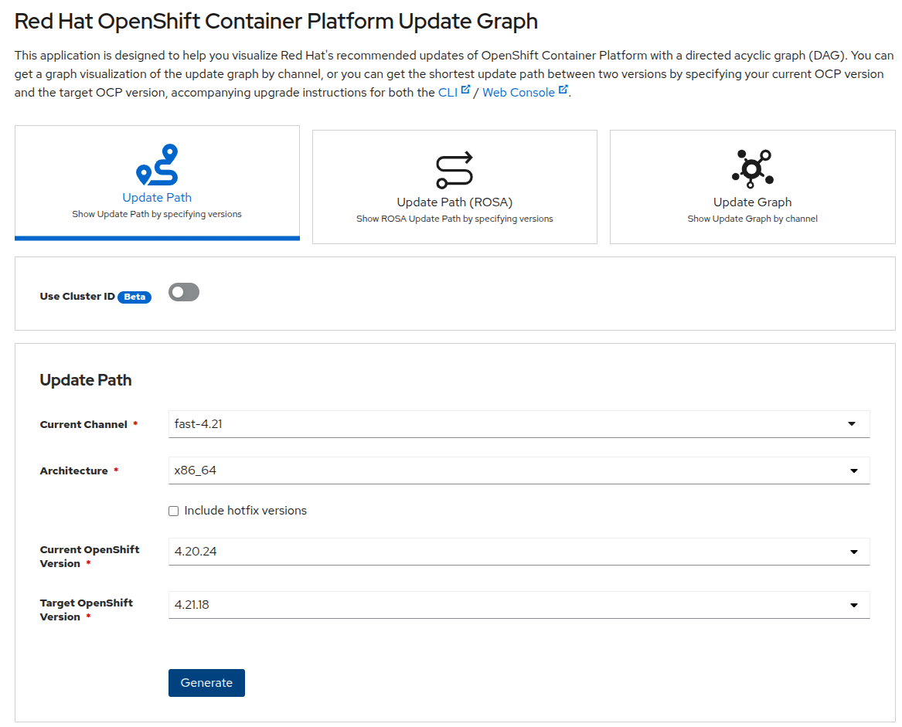
Using version 4.21 as an example, the following update channels are available:
- Fast channel (fast-4.21): This channel is updated with new versions of OpenShift Container Platform as soon as Red Hat declares them generally available (GA). These releases are fully supported and intended for use in production environments.
- Stable channel (stable-4.21): Releases are added to the stable channel after a delay from when they were published in the fast channel. During this delay, data is collected from multiple sources and analyzed for product regressions. Once enough data is collected and stability is verified, the release is promoted to the stable channel. Newly installed clusters use the stable channel by default.
- EUS channel (eus-4.y): Offered for all even-numbered minor versions, this channel provides Extended Update Support (EUS). When releases are promoted to the stable channel, they are simultaneously promoted to the EUS channel. The primary purpose of this channel is to serve as a convenience for clusters performing a Control Plane Only update (jumping between even-numbered EUS versions).
- Candidate channel (candidate-4.21): This channel provides unsupported, early access to releases as soon as they are built. Candidate releases might lack the full feature set of eventual GA releases, have not gone through full Red Hat Quality Assurance, and might not offer update paths to later GA releases. This channel is strictly suitable for testing purposes where destroying and recreating a cluster is acceptable.
How to upgrade your OpenShift cluster.
- Navigate to Administration > Cluster Settings in the Administrator perspective. Show the visual update graph. Initiate a minor or patch update. Watch the Machine Config Operator take over: it automatically cordons a node, drains the containers, applies a transactional OS image upgrade, reboots the node, checks its health, and uncordons it—moving through the cluster with zero workload downtime.
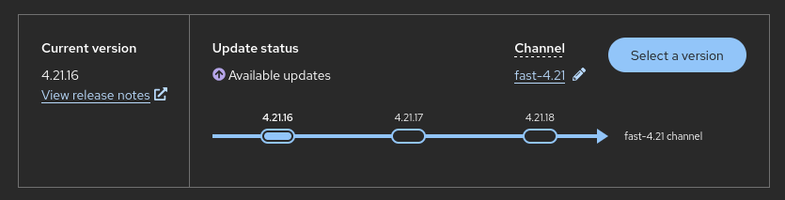
Advantages:
- Simplified, Full-Stack Automation: Because OpenShift completely controls the systems and services running on each machine—including the Red Hat Enterprise Linux CoreOS (RHCOS) operating system—upgrades are managed from a central control plane and are designed to be automatic events,. You can update an entire cluster with a single operation via the web console or the OpenShift CLI.
- Atomic, Over-The-Air (OTA) OS Updates: Operating system updates are delivered as a bootable container image using OSTree as a backend. Actual OS changes are applied in-place on each machine as an atomic operation, which reduces the burden on operations teams. If something goes wrong with the OS upgrade, a single rollback and reboot easily returns the system to the previous state.
- Minimal Disruption to Workloads: The MCO updates nodes in a rolling manner to ensure cluster capacity is minimally impacted. It respects the maxUnavailable field on the machine configuration pool to control how many nodes are updated simultaneously, ensuring workloads are safely drained and rescheduled.
- Safe and Verified Update Paths: To ensure only compatible updates are provided, a release verification pipeline automatically tests each release artifact for compatibility with supported cloud platforms, system architectures, and component packages before OSUS recommends it to your cluster. Furthermore, the CVO runs precondition checks before applying an update to ensure no problematic conditions are detected.
- Logical Dependency Management: By enforcing Runlevels, the CVO ensures that dependencies are strictly obeyed (for example, creating a CustomResourceDefinition before its corresponding custom resources are deployed) and that components can be updated in parallel when safe to do so

✔️ Self-Sustaining Hardware: The Machine API
The Machine API is a combination of primary resources based on the upstream Cluster API project alongside custom OpenShift Container Platform resources. It performs all node host provisioning and management actions after a cluster is installed, providing an elastic, dynamic provisioning method across public or private cloud infrastructures.
The Machine API operates using two primary resources:
- Machines: A fundamental unit that describes the host for a node, utilizing a providerSpec to define platform-specific metadata and configurations.
- MachineSets: Groups of compute machines that function similarly to how replica sets manage pods. If you need to scale compute nodes up or down, you simply adjust the replicas field on the MachineSet
Additionally, the API leverages custom resources like the Machine autoscaler, Cluster autoscaler, and Machine health checks to automatically scale nodes based on workload policies and automatically replace damaged or unhealthy machines. This entire capability is maintained by the Machine API Operator.
Advantages for Operators
The Machine API provides several powerful mechanisms and integrations for Kubernetes Operators managing complex workloads or cluster components:
- Advanced Lifecycle Control: Operators can utilize preDrain lifecycle hooks to pause operations at specific points in a machine's lifecycle. For example, an Operator can use a hook to ensure a replacement machine is successfully created and joined to the cluster before an old machine instance is removed, mitigating workload disruptions.
- Custom Draining Logic: Instead of relying on the default machine controller draining logic, an Operator can use a preDrain hook to replace it with a custom drain provider. This gives the Operator much greater flexibility and control, allowing it to prioritize the eviction of mission-critical applications before draining the rest of the node.
- Safe Control Plane Modifications: The API's architecture allows the Machine API Operator to safely create and remove control plane machines without requiring specific operational knowledge of core underlying components. For instance, this mechanism grants the etcd Operator precise control over managing the etcd quorum while control plane nodes are being safely deleted or replaced.
- Seamless Autoscaler Integration: The Machine API acts as a generic out-of-tree provider for higher-level Operators like the cluster autoscaler. By populating specific identification fields like the providerID, the autoscaler can compare machine configurations directly to cluster nodes, allowing it to successfully identify and clean up machines that failed to register as Kubernetes nodes
Example: Scaling the infrastructure
- Log into the Administrator Perspective.
- Navigate to Compute > MachineSets.
- Notice that the infrastructure is represented right here as a standard Kubernetes resource. If you want to change the underlying instance type, add labels, or scale up our data center, you don't touch your cloud provider. You interact with this MachineSet object.
- Click on one of your worker MachineSets
- Click the Actions dropdown in the top right and select Edit Machine Count.
- Increase the count from 2 to 3. Click Save.
- Immediately navigate to Compute > Machines.
- Show the new entry in the list displaying a status of Provisioning.
Example: Self healing
- Navigate to Compute > Machines and pick a healthy worker machine. Note its name.
- Go to your cloud provider console and Force Terminate that specific virtual machine instance. (Simulating a hardware rack failure or cloud outage).
- Return instantly to the OpenShift Console under Compute > Machines.
- Watch the targeted Machine transition into a Failed or Missing state.
- Within roughly 60 seconds, point out that a brand new machine has automatically been spawned by the MachineSet to replace the dead one.

✔️ Intelligent Cluster Troubleshooting (OpenShift Lightspeed)
Red Hat OpenShift Lightspeed is a generative AI-powered virtual assistant integrated directly into the OpenShift Container Platform web console through a natural-language interface.
For operators and cluster administrators, OpenShift Lightspeed provides several key benefits that make managing the platform easier for beginners and more efficient for experienced professionals:
- Proactive Issue Identification and Resolution: OpenShift Lightspeed continuously analyzes cluster data (gathered by the Insights Operator) to detect potential issues that could negatively impact cluster security, performance, availability, or fault tolerance. If issues are found, the Red Hat Lightspeed advisor service groups them by risk level and provides detailed explanations and tailored resolutions to solve the problem.
- Workload Configuration Insights: By integrating with the Deployment Validation Operator (DVO), OpenShift Lightspeed can highlight specific application workloads whose configurations might lead to cluster health issues. Administrators can view runtime violations of deployment policies and get recommendations directly within the advisor service.
- Context-Aware Troubleshooting: When managing multicluster environments, operators can use the Attach feature to automatically add relevant cluster resource details (such as YAML files from ManagedCluster and ManagedClusterInfo resources) as context to the AI agent's conversation. This allows the assistant to provide highly specific and relevant answers to complex questions.
- Centralized Visibility: Operators do not need to leave the OpenShift web console to monitor cluster health. The Home Overview page features a Red Hat Lightspeed Status card that summarizes the number of potential issues grouped by risk, offering direct links to detailed reports in OpenShift Cluster Manager.
💡NOTE: The Service does not provide the LLM for you, so you must configure the LLM before installing the OpenShift Lightspeed Operator. The OpenShift Lightspeed Service can rely on OpenAI, Microsoft Azure OpenAI and IBM watsonx as SaaS LLM providers. For this workshop we are using a self hosted model so we can explain to the customer how to configure it.

INSTRUCTIONS TO CONFIGURE LIGHTSPEED WITH A SELF HOSTED MODEL FROM models.corp
Check all details from models.corp here
- Install the OpenShift Lightspeed Operator from Ecosystem -> Software Catalog
- Create an account in models.corp
- Select one of the models from https://developer.models.corp.redhat.com/admin/applications (I am using qwen3-14b)
- Access your application to get your token
- Go back to OpenShift and create a Secret with your token in the openshift-lightspeed namespace:
apiVersion: v1
kind: Secret
metadata:
name: openai
namespace: openshift-lightspeed
type: Opaque
stringData:
apitoken: <your_api_token>
- Create a ConfigMap with the Red Hat certificates to access the model:
kind: ConfigMap
apiVersion: v1
metadata:
name: trusted-certs
namespace: openshift-lightspeed
data:
caCertFileName: |
-----BEGIN CERTIFICATE-----
.
. < paste certificate contents here >
.
-----END CERTIFICATE-----
- Create an OLSConfig in the Installed Operators page, accessing the OpenShift Lightspeed Operator:
apiVersion: ols.openshift.io/v1alpha1
kind: OLSConfig
metadata:
name: cluster
spec:
llm:
providers:
- name: modelsCorp
type: openai
credentialsSecretRef:
name: openai
url: 'https://qwen3-14b--apicast-production.apps.int.stc.ai.prod.us-east-1.aws.paas.redhat.com/v1'
models:
- name: Qwen/Qwen3-14B
ols:
defaultModel: Qwen/Qwen3-14B
defaultProvider: modelsCorp
- Check that OpenShift Lightspeed is installed and ready

Example 1: CrashLoopBackOff — most visual, most common real-world issue
- Create a new project, demo-lightspeed
- Create a new pod with this content (it is forcing the pod to exit):
apiVersion: v1
kind: Pod
metadata:
name: bad-app
spec:
containers:
- name: app
image: busybox
command: ["sh", "-c", "echo starting && exit 1"]

- See how the pod is in CrashLoopBackOff state
- Open Openshift Lightspeed and ask: “My pod bad-app is in CrashLoopBackOff, what's wrong?”
- It will probably ask you for the logs

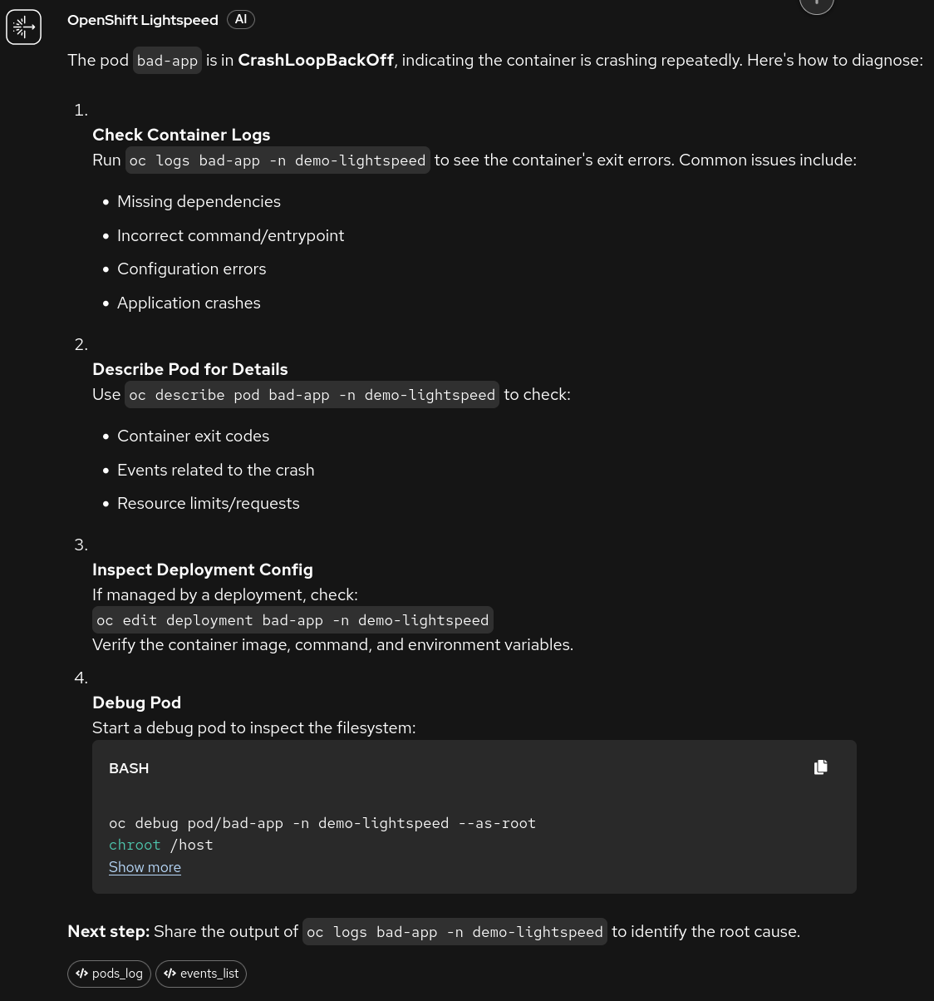
- Provide the logs and see how it locates the issue and proposes a fix

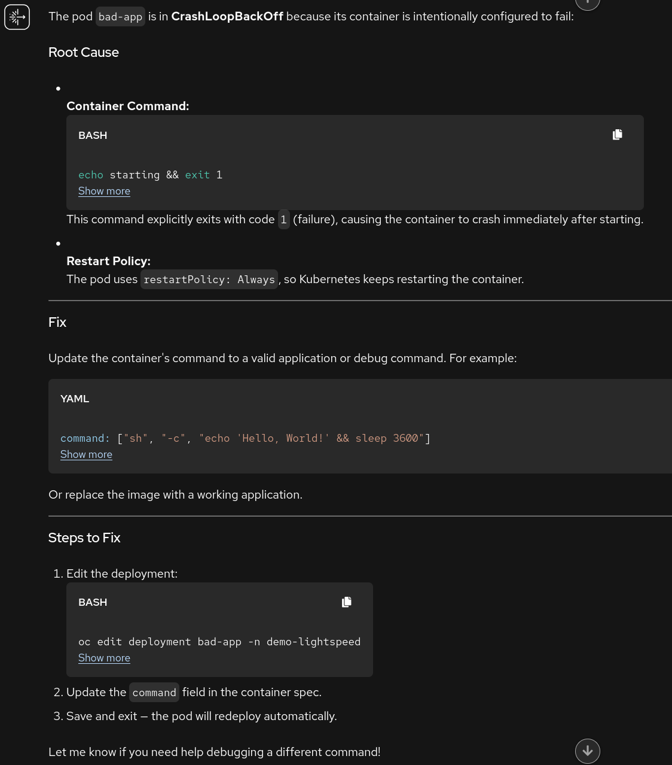

- Modify the pod as instructed and try again.

Example 2: ImagePullBackOff — fast to trigger, immediately visible

- Create a new deployment with this content (image does not exist):
apiVersion: apps/v1
kind: Deployment
metadata:
name: broken-deploy
spec:
replicas: 1
selector:
matchLabels:
app: broken
template:
metadata:
labels:
app: broken
spec:
containers:
- name: app
image: myregistry.internal/nonexistent:v99

- Check the pod that it created in the Pods page and check that it is failing.
- Ask OpenShift Lightspeed: “Why can't my deployment broken-deploy start?“
- See how Lightspeed finds the issue:

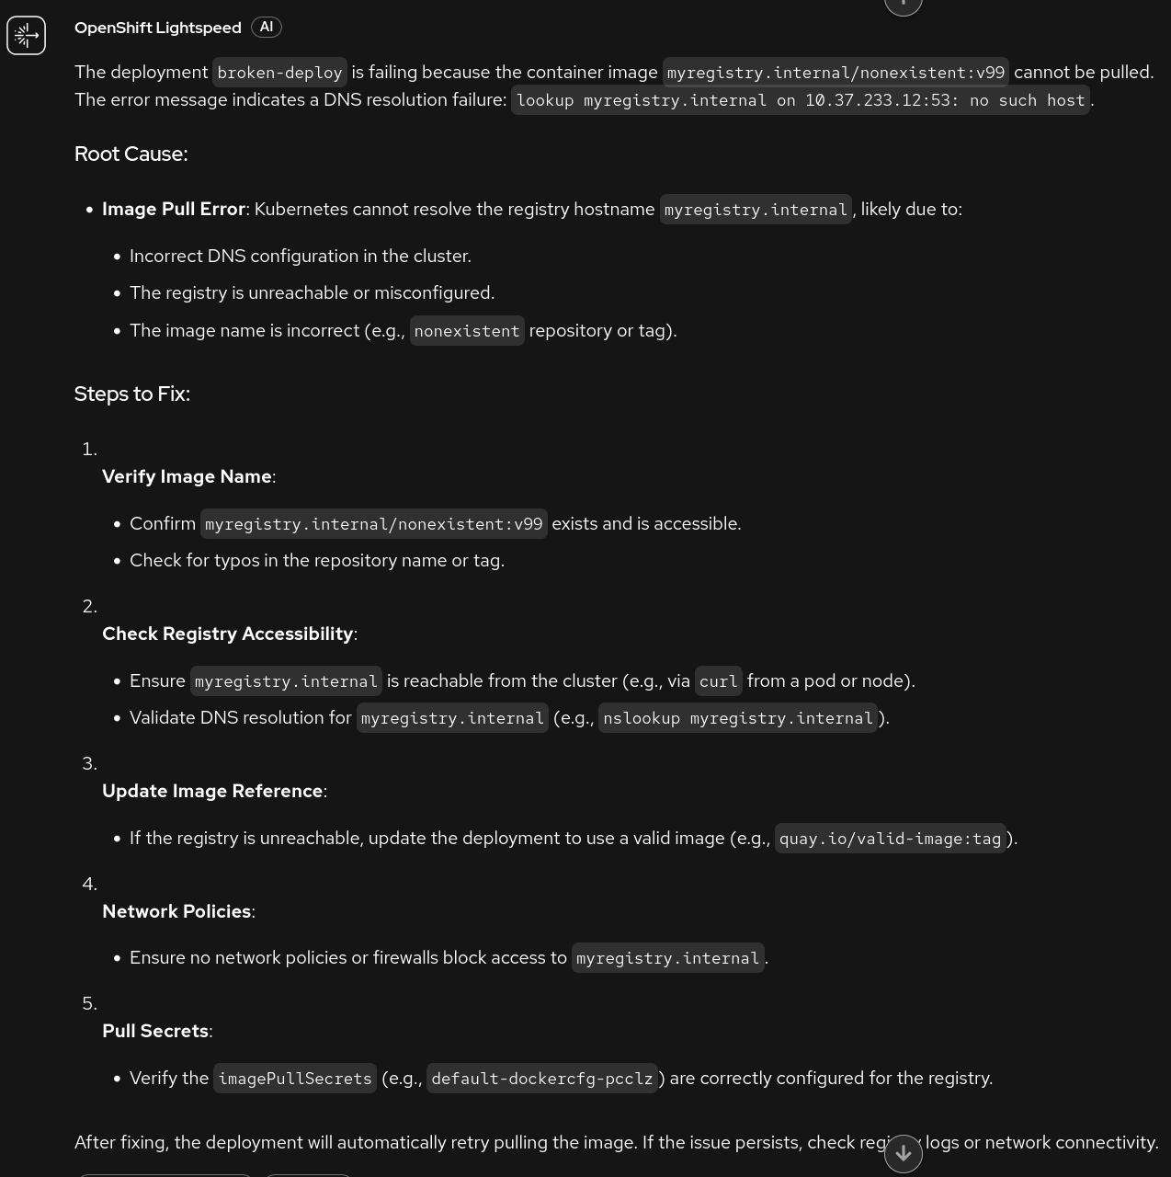

Example 3: Broken liveness probe — showing Lightspeed’s depth

- Create a new deployment with this content

apiVersion: apps/v1
kind: Deployment
metadata:
name: probe-fail
spec:
replicas: 1
selector:
matchLabels:
app: probe-fail
template:
metadata:
labels:
app: probe-fail
spec:
containers:
- name: app
image: registry.access.redhat.com/ubi9/nginx-120:9.8-1781010529
livenessProbe:
httpGet:
path: /healthz
port: 8080 # nginx listens on 80, not 8080
initialDelaySeconds: 5
periodSeconds: 5

- Check the pod that it created in the Pods page and check that it is failing.
- Ask OpenShift Lightspeed: “My nginx deployment keeps restarting but the image is fine, why?“
- See how Lightspeed finds the issue:

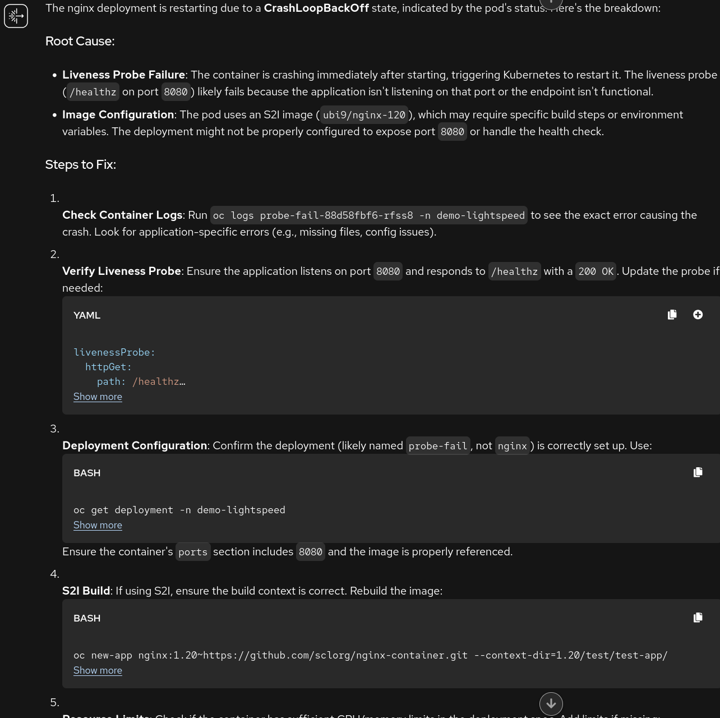

Module 5 - Advanced Cluster Management
Refer to the RHACM Demo Script - RHDP

Module 6 - Advanced Cluster Security (RHACS)
Refer to the Red Hat ACS Updated 4.8 Demo Script

TESTING

General
- Will probably need to add more nodes for the infrastructure module
- Version installed 4.20.36

Module 1
- No different perspectives
  - Install virtualization and fleet management. See if it can be automated on provisioning.

